Anti-epidemic measures for schools at all levels in the Fall Semester 2022
(according to the 1110822 announcement of Ministry of Education )
Categories | Management time and methods | Campus Control Methods
PCR positive or rapid test positive  (7+7) | Implement 7-day home care (returning home is advised and recommended. If students stay in school, those who rent an off-campus place must stay in the residence, and those who live in dormitories will be arranged to live in an isolated dormitory. Confirmed cases tested on the same day can share a room ).  After 7 days, if no symptoms remain, students can go back to classes. | 1. It is forbidden to go out and enter the campus during the 7-day home care period.  2. Those who do not have remaining symptoms after 7 days can enter the school for classes (no rapid tests required).
Those who engage in activities with the confirmed cases (and rapid-test positive cases) without masks on for more than 15 minutes | The school provides 1 set of rapid test kit for each person in the Dormitory Service Center (open all day). Those who are negative in the rapid tests and asymptomatic can enter the class. If they have symptoms, they should seek medical treatment as soon as possible. | Those who are negative in rapid tests and do not have symptoms can enter the school and attend classes.
Those who engage in activities with the confirmed cases (and rapid-test positive cases) with masks on throughout the whole process | Self health monitoring is required. | Those who do not have symptoms can enter school and classes.
People living together with the confirmed case (including roommates sharing the same dorm room)  (0+7 or 3+4) | 1. Those who have received 3 doses of vaccination and are negative in the rapid tests are exempted from home isolation. They can undergo self-prevention in the original dormitory for 7 days.  2. Those who have not received 3 doses should undergo home isolation for 3 days and then practice self-prevention for 4 days in the isolation dormitory.  3. Those who are undergoing home isolation can not enter the school (resident students can not leave the isolation dormitory), and they can not enter classes during the self-prevention period as well.  4. Each person can apply to the Residential Service Center (open all day) for 2 sets of rapid test kits. | 1. People undergoing home isolation is not allowed to enter the school (residential students can not leave the isolation dormitory).  2. Those who are negative in their rapid tests and show no symptoms during the self-prevention period can enter the school, but are not allowed to attend classes or enter public places such as libraries, health and leisure centers, etc.  3. After 7 days of home isolation, students can enter the classes if they do not have any symptoms left.

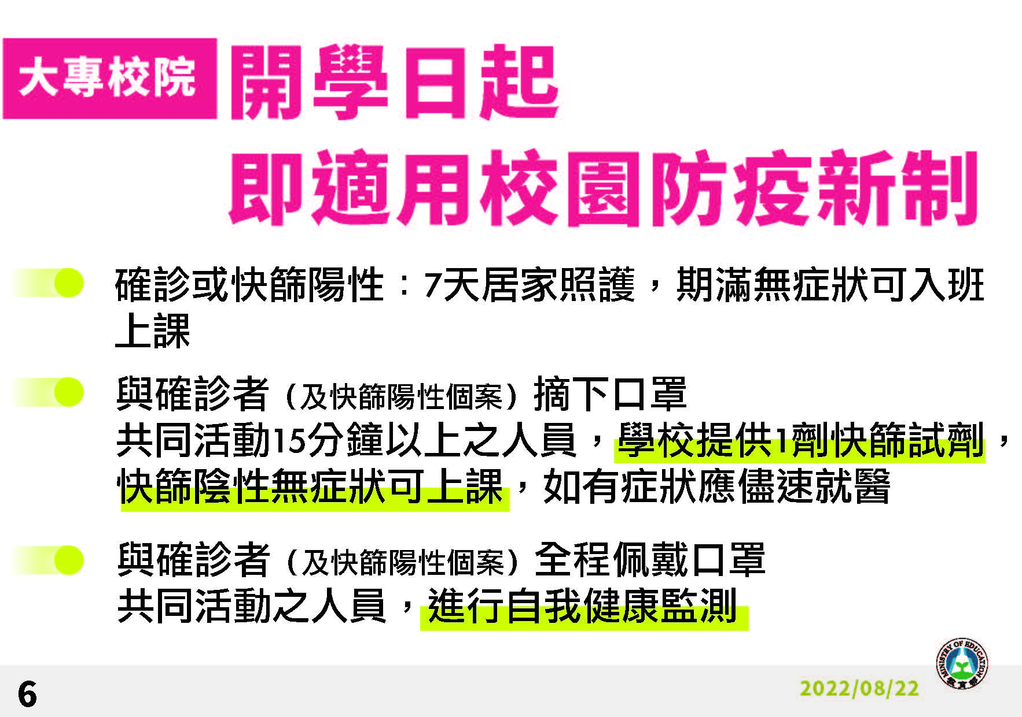

For Higher Education Institutes
From the first day of school, new Covid-19 prevention regulations for campus are applied.

- For Comfirmed cases or people with positive results in rapid tests: Implement 7-day home care . After 7 days, if no symptoms remain, students can go back to classes.
- Those who engage in activities with the confirmed cases (and rapid-test positive cases) without masks on for more than 15 minutes: The school provides 1 set of rapid test kit for 1 person in the Dormitory Service Center (open all day). Those who are negative in the rapid tests and asymptomatic can enter the class. If they have symptoms, they should seek medical treatment as soon as possible.
- Those who engage in activities with the confirmed cases (and rapid-test positive cases)
with masks on throughout the whole process: Self health monitoring is required.

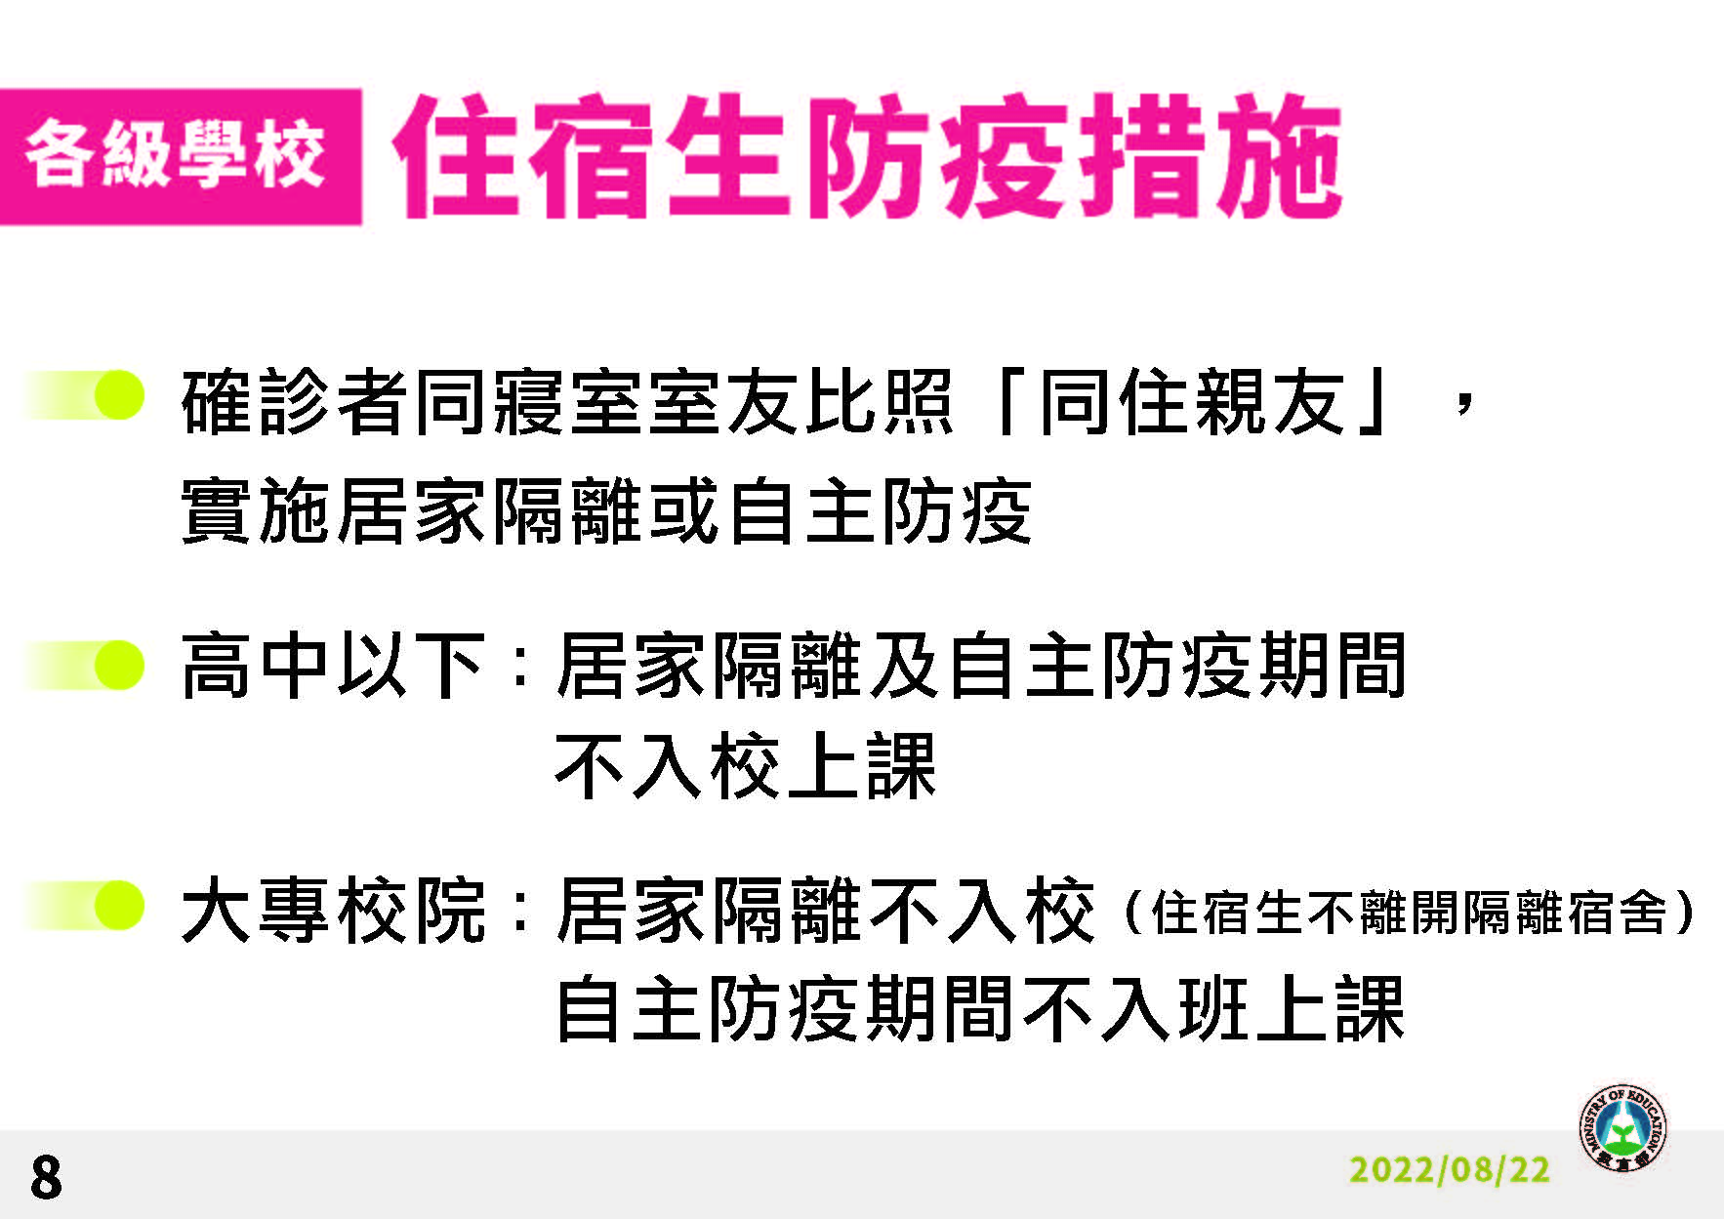

Covid-19 Prevention Regulations for Resident Students on Campus

- People living together with the confirmed case (including roommates sharing the same dorm room): Home isolation or self-prevention is required.
- For k-12 and preschool students: students can not enter schools during home isolation and self-prevention periods.
- For higher education students: students can not enter the school (resident students can not leave the isolation dormitory), and they can not enter classes during the self-prevention period as well.

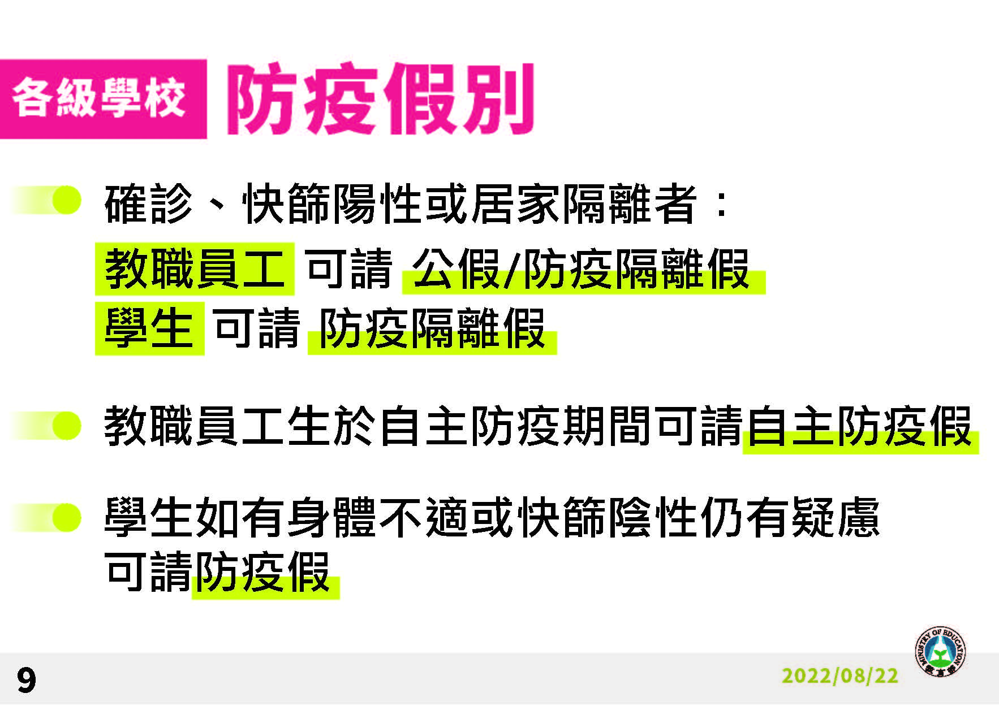

Kinds of Covid-19 Prevention Leaves

- For Comfirmed cases or people with positive results in rapid tests or people undergoing home isolation: school faculty and staff can take official leaves or Covid-19 prevention leaves; student can take Covid-19 prevention leaves.

- School faculty, staff and students can all take self-prevention leaves during the self-prevention periods.

- Student who do not feel well or who have health converns despite negative results in their rapid tests can take prevention leaves.

